A Data Science Approach to

Forecast Electricity Consumption in Australia

Brendan Chick (z5632728),
Daniel Heath-Ogden (z5623647),
Kam Kit Lau (z5618444),
Kelvin Yim (z5502200).
24/03/2026

Table of Contents
1 Introduction and Motivation 3
2 Preliminary Literature Review 3
3 Methods, Software and Data Description 4
4 Activities and Schedule 5
5 Team Roles 5
Appendix 1 - Expected Contribution 6
Appendix 2 – Expertise of Team Membrers 6
References 6

1 Introduction and Motivation
Accurate electricity demand forecasting is critical for grid stability, efficient market operations, and resource allocation. Inaccurate estimates risk costly power shortages and inefficient generation scheduling.
This project addresses this complex time-series problem by forecasting electricity demand in New South Wales (NSW), Australia. Electricity demand is influenced by multiple factors including seasonal trends, daily consumption patterns, weather conditions, and behavioural patterns of electricity users. These characteristics make electricity demand forecasting a complex time-series problem. In this project we focus on long-horizon forecasting, where multiple future time steps are predicted simultaneously. We aim to focus on long-horizon forecasting—specifically predicting 55 days of demand simultaneously (WIP: add supporting literature for the 55-day window). This extended forecasting horizon is highly relevant for real-world decision-makers and energy planners.

Research Objective
The primary objective is to evaluate if modern machine learning architectures provide meaningful performance improvements over traditional methods.
Main Research Question:
Can transformer-based models improve long-horizon electricity demand forecasting accuracy compared with traditional statistical models and recurrent neural networks?
To answer this, the project will compare three distinct methodologies:
- SARIMAX: A classical statistical time-series model.
- LSTM: A recurrent neural network designed for sequential data.
- PatchTST: A modern, transformer-based deep learning architecture.

2 Preliminary Literature Review
The validity of using early transformer architectures for long-term time-series forecasting was heavily challenged in 2022. Researchers (Li et al., 2022; Zeng et al., 2022) demonstrated that simpler statistical methods and networks consistently outperformed them. However, PatchTST (Nie et al., 2023) successfully regained traction for transformer models by addressing key architectural limitations.
PatchTST is specifically optimized for time-series data through two major innovations:
- Patching: Instead of individual time-steps, it divides the series into fixed-length patches, drastically reduces sequence length, allowing the model to learn temporal patterns efficiently by reducing the operations required for attention calculations.
- Channel Independence: Predictor variables are fed into the forward pass separately, acting as a crucial regularization step, offering the advantage of reduced overfitting via shared weights compared to previous transformers.
Beyond these changes, it largely follows the vanilla transformer structure (Vaswani et al., 2017) with minor modifications, such as utilizing BatchNorm instead of LayerNorm.
To rigorously evaluate PatchTST, we will benchmark it against established forecasting models:
- SARIMAX (Classical Statistical): Historically relied upon for its interpretable and highly effective modelling of trends and seasonality (Box et al., 2015). It allows for external explanatory variables (e.g., weather) but inherently struggles with nonlinear relationships and long-range temporal dependencies.
- LSTM (Deep Neural Network): Highly popular for analyzing sequential data. Its gating mechanisms (Hochreiter & Schmidhuber, 1997) retain information across longer intervals. However, it is strictly sequential processing limits its ability to efficiently capture complex, long-range dependencies compared to transformers.
Because the foundational research comparing these transformer architectures relied on a single Portuguese electricity dataset¹, it is beneficial to validate these findings to the targeted NSW dataset. By evaluating PatchTST alongside SARIMAX and LSTM, we will determine if it yields improved predictive performance for this specific domain.

3 Methods, Software and Data Description
3.1 Proposed Models
As the data follows a time-series, SARIMAX, LSTM and PatchTST will be implemented and compared—see Section 2. SARIMAX will serve as the baseline model.
3.2 Data Description
The project utilizes historical electricity demand data from New South Wales (NSW), spanning approximately the past ten years.
- Target Variable: Electricity Demand (MW).
- Explanatory Variables: Temperature and temporal features (time of day, day of week, month, year).
Incorporating these variables is expected to improve forecasting accuracy by explicitly capturing seasonal and behavioural consumption patterns.
3.3 Methodology
- Exploratory Data Analysis (EDA): Examine seasonal patterns, demand cycles, and the critical relationship between temperature and electricity demand.
- Data Processing & Splitting: The dataset will be cleaned, pre-processed appropriately for each model, and subsequently split into training, validation, and testing sets.
- Forecasting Horizon: Supported by <literature>, we will predict 55 days of forward demand simultaneously. This diverges from rolling one-step forecasting to better reflect real-world planning scenarios required for planning ahead.
- Training & Robustness: Models² will be trained and tuned on their respective splits. To ensure robustness, the process will be repeated using multiple pre-defined seeds to compute the mean and standard deviation of the results.
- Evaluation Metrics: Model performance will be evaluated and compared using Root Mean Square Error (RMSE) and Mean Absolute Error (MAE) aligning with the literatures reviewed in Section 2.
3.4 Software & Tools
The project relies on Python and Google Colab Notebooks for all analysis and modelling, chosen for the team's familiarity and Python's rich ecosystem for statistical and deep learning.
- Core Libraries: pandas, numpy, matplotlib, scikit-learn.
- Modelling Frameworks: statsmodels (SARIMAX), PyTorch or TensorFlow (LSTM), and open-source repositories for PatchTST.
- Documentation & Presentation: The final report will be in LaTeX or polished notebooks. Presentations will utilize PowerPoint and recorded via Teams / Zoom.
- Collaboration: Teams for meetings and communications. GitHub for collaboration and version control.

4 Activities and Schedule
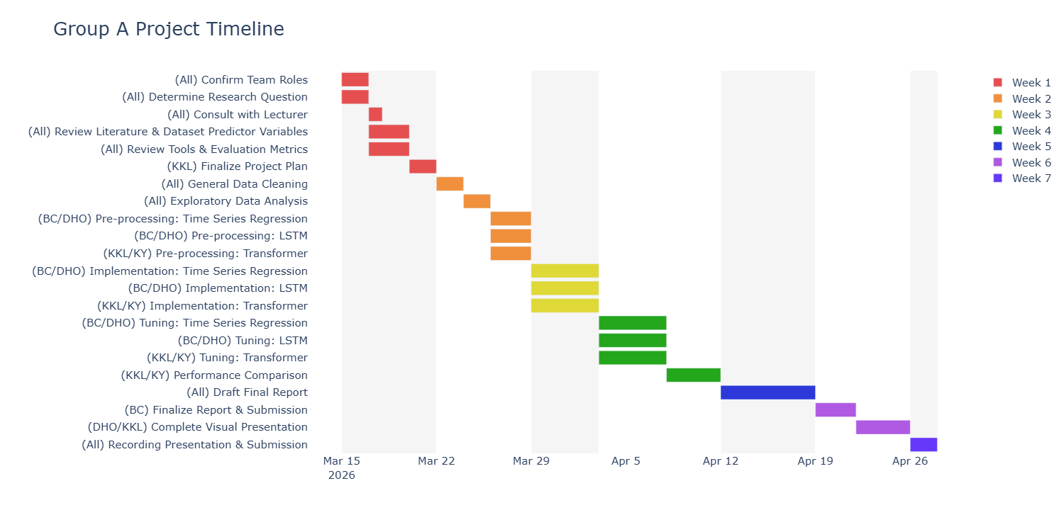
Each task is prefixed with a team members’ initial.
- Weeks 1 & 2 involve all team members up until pre-processing of data for their respective model.
- Weeks 3 & 4 continue with the implementation and tuning of the models. Then, their results are consolidated, and comparisons are made as described in section 3. Drafting of the final report will also begin.
- Week 5, finalization of the report with Brendan overseeing process.
- Weeks 6 & 7 are used for the final presentation of the project.

5 Team Roles
Member | Role / Responsibilities | Reasoning
Brendan | Research Consultant / Lead¹ and Model analysis of SARIMAX + LSTM | Comprehensive research experience from PhD
Daniel | Presentation/Communication Lead² and Model analysis of SARIMAX + LSTM | Teaching and tutoring experience
Kam | Project Manager, Presentation/Communication Lead³, Model lead of PatchTST + Comparison | Highschool teaching + leadership experience as an actuary + UNSW Deep Learning course experience
Kelvin | Logistics coordinator³ and Model lead of PatchTST + Comparison | Stakeholder management experience from job + UNSW Deep Learning course experience

Responsibilities were allocated based on the individual expertise of team members (refer to Appendix 1). Note that all team members have data analytics experience from UNSW course and/or their occupations and therefore are responsible for various parts of data modelling and analysis.

Appendix 1 – Mind Map of Expertise of Team Members
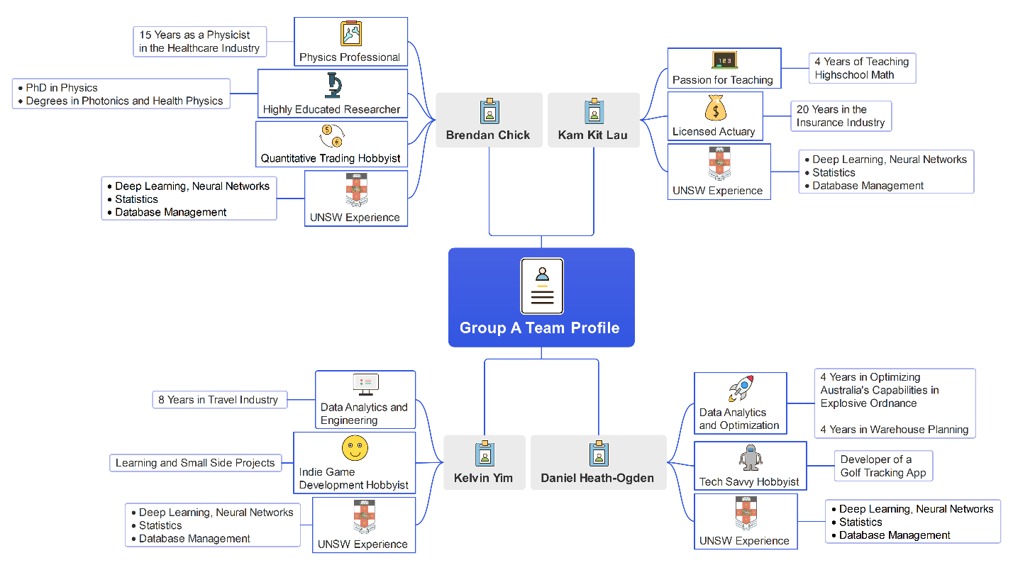

References
- Box, G. E. P., Jenkins, G. M., Reinsel, G. C. and Ljung, G. M. (2015). Time Series Analysis: Forecasting and Control. Wiley.
- Hochreiter, S. and Schmidhuber, J. (1997). “Long Short-Term Memory.” Neural Computation, 9(8), pp. 1735–1780.
- Li, H., Shao, J., Liao, K., & Tang, M. (2022). Do simpler statistical methods perform better in multivariate long sequence time-series forecasting? In Proceedings of the 31st ACM International Conference on Information & Knowledge Management (pp. 4168–4172). Association for Computing Machinery. https://doi.org/10.1145/3511808.3557585
- Nie, Y. et al. (2023). “A Time Series is Worth 64 Words: Long-term Forecasting with Transformers.” International Conference on Learning Representations.
- Vaswani, A., Shazeer, N., Parmar, N., Uszkoreit, J., Jones, L., Gomez, A. N., Kaiser, Ł., & Polosukhin, I. (2017). Attention is all you need. Advances in Neural Information Processing Systems, 30. https://doi.org/10.48550/arXiv.1706.03762
- Zeng, A., Chen, M., Zhang, L., & Xu, Q. (2022). Are transformers effective for time series forecasting? arXiv. https://arxiv.org/abs/2205.13504

